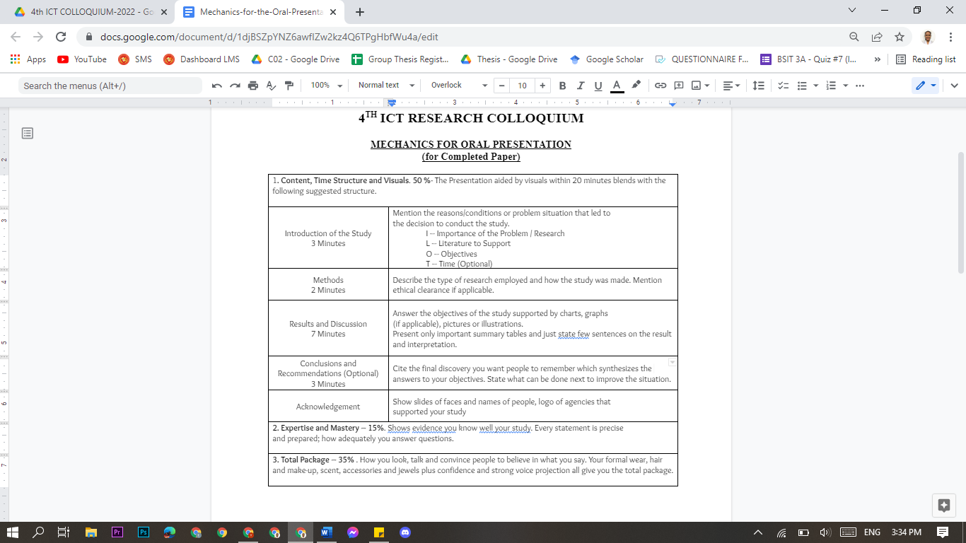

SCRIPT

**(AG) Introduction (3 mins)**

Good day, Everyone!

We are the Group C02 from the BS Information Technology 4-A, and we are here to present and demonstrate our study, which is the #3lb: A 117 Emergency Communication Platform for Abuse Report, in a Mobile Application.

And let us introduce ourselves, I am Arlene Grace C. Alonzo

Right from the very beginning of the Covid-19 Pandemic, and according to several related reports, there was an increase in domestic violence or abuse involving Women, Children and Older People. Putting them into a greater risk of experiencing abuse at home. But what is an abuse? What are the types of abuse? Is there a law that can accomodate abuse cases?

**Abuse** is an act of violence and or maltreatment towards a person or thing. Or a repeated act of violence towards a person.

And there are (4) main types of abuse in the Philippines

(the **physical abuse,** **sexual abuse,** **psychological abuse** and lastly, **economic abuse**

and that is all according to Republic Act No. 9262, which is the Anti-Violence Against Women and their Children Act of 2004. Which is inline with the government's purpose, of helping women and their children from violence before pandemic and even more now. And as reflected in the data analysis last september 2020, the Philippines resulted with high growth of online searches, relating to abuse or violence during the pandemic.

And that is why with this supporting reports, our group conceptualized an application entitled #3lb: A 117 Emergency Communication Platform for Abuse Report, in a Mobile Application

**(RESEARCH OBJECTIVES)**

The research objectives of the study are to provide the following:

The contact information and the office location of the local authorities, where the victim and witnesses can file a report.

A mobile application that helps victims to report their difficult situation and is easily accessible.

Provide accurate data of cases to deliver comfort and support service to the victims.

And provide a system that can raise awareness with discrete classification of abuse and violence, with the help of the system’s gathered data.

**METHODOLOGY (2 mins)**

The researchers used mixed method research, combining qualitative and quantitative-descriptive type of approaches, as for the purpose of the proposed study is to serve as a helpful way of reporting abuse cases through a mobile application and also to gather data regarding the abuse cases in the target locale.

The researchers used agile methodology for software development of the application, which emphasizes the collaboration of the group, user feedback, continuous improvement, and the adapting capacity to changing activity.

The research instruments were in the form of a self-made survey questionnaire through Google Forms and Interview. The researchers conducted a virtual interview with a former Women and Children Protection Desk Officer from Lubao, to know the current process of filing a complaint against an abuser, and the basic information needed for the complaint. For the survey questionnaires, All questions were made to be answerable by Likert scale. There were three (3) types of questionnaires: for victim or witness, for police and for ordinary Pampanga residents. The questionnaires were distributed to various respondents of the locale, with the characteristics as follows; thirteen (13) years old and above, residing in the municipalities located in the 2nd District of Pampanga (Floridablanca, Guagua, Lubao, Porac, Santa Rita, and Sasmuan), victims or witnesses of abuse, male, female or LGBTQ+.

Lastly, International Organization for Standardization (ISO) / International Electrotechnical Commission (IEC) 25010 was used as a reference in crafting the evaluation for the system, to determine the user’s likelihood to accept the study, in terms of functional stability, performance efficiency, usability, reliability, and security of the mobile application. All gathered data was then analyzed using the weighted mean and then interpreted.

**RESULTS AND DISCUSSION (7 mins)**

1st R&D slide  
For the first question, 42% of the respondents strongly disagreed and 29% of the respondents disagreed with the statement that the available emergency hotlines for filing abuse cases are easy to find and use.

2nd Slide

In here, the data show that 77%



Read sa ppt

3rd R&D slide

While in here, we have 67% of the respondents strongly agree that they often see or hear information about hotlines from social media platforms.

3rd R&D slide

The bar graph shows the results of the survey questionnaire for the Pampanga residents, with 82% of the respondents agreeing to look forward to using an application that can provide an emergency communication platform.

Through the pre-survey questionnaires, the researchers were able to gather the results that supported the aim of the study. The different questionnaires sorted out the desirable results that helped the researchers to identify the proper solution to the identified problem.

SUMMARY OF RESULTS (under results and discussion pa rin)

For the summary of the result, the representation indicates that the proposed system impact has an average mean of 3.73, which corresponds to an interpretation level equivalent to “Strongly Agree”, specifying that the proposed system’s average mean (3.73) compared to the existing system’s average mean (2.52), with an interpretation level of “Agree” had a difference of (1.21) in the average mean, where in the proposed system resulted higher, this signifies that the proposed system has a greater impact and advantage to the users than the existing system in terms of functional stability, reliability, usability, performance efficiency and security.

The result of the survey conducted showed that the majority of the respondents strongly agreed to the proposed system compared to the existing system. These are the following objectives of the study that were achieved by the system.

* Firstly, the application offers a complaint report function through the use of the internet.
* And also, with the use of the application, the database of the complaint reports will be organized. as the application only focuses on submitting reports and also giving reliable information for better awareness of the people.
* One of the objectives of the study is to provide accurate information about the local authorities such as their telephone numbers and their office locations.
* Also the application can provide information about the nearby facilities that could help for the betterment of a person’s well-being.
* And the application has an information board that also tackles on how to identify if a person is being abused and what are the ways to report the abuse and how to stop it.

And all of these are utilized in one application that will give benefit to the users.

With the use of the proposed system, the user will be able to seek help with the use of the internet. Well, the existing system’s function is still serviceable but based on the survey conducted, it shows that the existing system still has room for improvement.

**CONCLUSION, and RECOMMENDATION (3 mins)**

**CONCLUSION**

The overall study was concluded successful, as the aim and objective of the #31b: A 117 Emergency Communication Platform for Abuse Report in a Mobile Application was met successfully.

The application was able to provide the following:

an additional way of submitting a complaint report to the authorities.

provide helpful information such as emergency hotlines, stations, institutions and facilities for the victims.

It also has an information board, that also tackles on how to identify if a person is being abused and what are the ways to report the abuse and how to stop it.

And the visual aesthetics of the application also helped in giving interest to the users.

As we can see here, in the evaluation survey, the respondents found out that they Strongly Agree in terms of security and usability both having an average mean of 3.77%, and functional stability with an average mean of 3.71%.

This result signifies that the proposed system has a greater impact and advantage to the users than the existing system. Therefore, the researchers concluded that the results are in line with the overall quality of the proposed system.

**RECOMMENDATION**

The researchers recommend implementing the study in the community by promoting the application through the use of social media and local authorities, by providing enough information on how useful the application is. The researchers also recommend the following improvements and additional upgrade features for the next researchers that would like to take the similar study.

Firstly, we have the enhancement of the administrator’s website and mobile application appearance, adding more functionality for data visualization, and also additional language support for local users. and also recommending new user sign-up authentication feature using the National Identification number issued by the Philippine Statistics Authority (PSA).

Secondly, is to use a different approach or System Development Life Cycle, that could possibly help the future researchers to achieve greater outcomes.

Thirdly, the use of multi-platform application development can address the accessibility and usability to different mobile operating systems, to accommodate and help more users.

Lastly, the researchers recommend adding a call feature to the application, this would enable the users to immediately report their situation. The respondents found the application useful despite its deficiencies. The process of improving the application features continues as it is being implemented in the community.

**One Minute Presentation of the System**

And here is the video demonstration sample of the #31b mobile application.

**Acknowledgement**

**The researchers would like to express their gratitude to the following:**

Don Honorio Ventura State University (DHVSU), together with the College of Computing Studies (CSS), also the Philippine National Police (PNP), and the Department of Science and Technology (DOST), thank you very much.

**(AG)**

That’s the end of our presentation, (smile dude) and again, good day everyone…